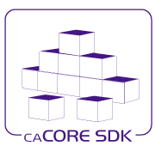

NCICB
caCORE SDK 4.5
Design Document
5/25/2012

[Type the abstract of the document here. The abstract is typically a short summary of the contents of the document. Type the abstract of the document here. The abstract is typically a short summary of the contents of the document.]

Contents
1. Purpose 3
2. Introduction 3
2.1 SDK 3
2.2 REST 4
2.3 JAX-RS 5
3. Architecture 6
3.1 Code generation 7
3.1.1 Configuration 9
3.2 SDK JAX-RS Resources 11
3.3 Representation 14
3.4 Content Handling 15
3.5 Error Handling 15
3.6 Security 15
3.6.1 Configuring Security 17
3.6 Discovery 19
3.7 Reference Implementation 19
3.8 Supporting existing Implementations 20

Document Change History
Version | Date | Changed by | Description
0.1 | 05/16/2012 | Prasad Konka | DRAFT Version
1.0 | 05/23/2012 | REVIEWED | Final Version. Reviewed by Larry Brem, Eugene Wang

Purpose
The purpose of this document is to provide design details for caCORE SDK 4.5 version. This version adopts JAX-RS standard to fully implement CRUD operations with RESTful architecture.

Introduction

SDK
The National Cancer Institute (NCI) Center for Biomedical Informatics and Information Technology (CBIIT) provides biomedical informatics support and integration capabilities to the cancer research community. CBIIT has created the caCORE Software Development Kit or caCORE SDK, a data management framework designed for researchers who need to be able to navigate through a large number of data sources. caCORE SDK is CBIIT’s platform for data management and semantic integration, built using formal techniques from the software engineering and computer science communities.
By providing a common data management framework, caCORE SDK helps streamline the informatics development throughout academic, government and private research labs and clinics. A caCORE SDK generated system is built on the principles of Model Driven Architecture (MDA) and specifically Model Driven Development (MDD) and n-tier architecture and consistent API. Model Driven Architecture (MDA) and MDD is a software development practice that uses a structured modeling language to describe the requirements, objects, and interactions of a data system prior to its construction. The use of MDA and n-tier architecture, both standard software engineering practices, allows for easy access to data, particularly by other applications.
Users of the caCORE SDK benefit in numerous ways. The primary benefits of using the caCORE SDK includes:
- Consistent UML representation of the data – Users of the caCORE SDK are required to represent their data in UML format. As a user of the SDK, the user is likely to maintain their UML model throughout the life cycle of the application. The same UML model can be used to quickly learn about the organization of the data at various levels in the application.
- Rapid data service generation – The SDK can generate caBIG silver-level compatible APIs quickly from the UML model. Once the UML model and the database are ready, SDK can quickly generate data service in a matter of hours. Manually building the application from the ground up can take several months to achieve the same functionality.
- Uniform way to access data – SDK-generated systems provide uniform access to the data stores. Other applications developed using the caCORE SDK have similar mechanisms to retrieve the data. Thus common data representation allows multiple applications to share data.
- Query using information model – SDK-generated systems allow queries to be written in various ways including using Query-By-Example. Since the query is independent of the system’s implementation, changes in the runtime systems do not affect the client application.
- Integrated Security with CSM – SDK generated system can be made secured with CSM. In addition to authentication and authorization configuration, CSM provides, class level, instance level, and attribute level security out of the box.

The caCORE SDK generated runtime system's infrastructure exhibits an n-tiered architecture with client interfaces, server components, backend objects, data sources, and additional backend systems. XML-JSON-HTTP Interface implements REST-like capability by serving requests over HTTP and returning formatted results as HTML, XML or JSON. SDK has adopted its own implementation of REST-like style through a custom Servlet that takes request with predefined query parameters and format. This Servlet process query requests, validates query format and its parameters, determine output format, query results using ApplicationService and convert results into desired format. This partial implementation support GET operation only.
The following sections introduce RESTful architecture and SDK design approach to the full implementation of RESTful architecture within SDK code generation and runtime modules. This proposed SDK design will support GET, POST, PUT and DELETE methods of HTTP and other standardized practices within RESTful architecture principles.

REST
REpresentational State Transfer (REST) is an architecture principle in which data and functionality are considered resources, and these resources are accessed using Uniform Resource Identifiers (URIs), typically links on the web. The resources are acted upon by using a set of simple, well-defined operations.

The basic REST design principle uses the HTTP protocol methods for typical CRUD operations:
- GET defines a reading access of the resource without side-effects. The resource is never changed via a GET request, e.g. the request has no side effects (idempotent).
- PUT creates a new resource, must also be idempotent.
- DELETE removes the resources. The operations are idempotent, they can get repeated without leading to different results.
- POST updates an existing resource or creates a new resource.
The major advantages of REST-services are:
- They are highly reusable across platforms (Java, .NET, PHP, etc) since they rely on basic HTTP protocol
- They use basic XML instead of the complex SOAP XML and are easily consumable
In the REST architecture style, clients and servers exchange representations of resources using a standardized interface and protocol. These principles encourage RESTful applications to be simple, lightweight, and have high performance.
JAX-RS (Java API for RESTful Web Services) is a Java programming language API that provides support in creating web services according to the Representational State Transfer (REST) architectural style. JAX-RS uses annotations, introduced in Java SE 5, to simplify the development and deployment of web service clients and endpoints. Following section gives brief introduction to JAX-RS.

2.3 JAX-RS
This speciﬁcation deﬁnes a set of Java APIs for the development of Web services built according to the Representational State Transfer (REST) architectural style. Following are the goals of JAX-RS specification:
- POJO-based: The API provides a set of annotations and associated classes/interfaces that may be used with POJOs in order to expose them as Web resources. The speciﬁcation deﬁnes object lifecycle and scope.
- HTTP-centric: The speciﬁcation assumes HTTP is the underlying network protocol and provides a clear mapping between HTTP and URI elements and the corresponding API classes and annotations. The API provides high level support for common HTTP usage patterns and will be sufficiently ﬂexible to support a variety of HTTP applications including WebDAV and the Atom Publishing Protocol.
- Format independence: The API is applicable to a wide variety of HTTP entity body content types. It provides the necessary pluggability to allow additional types to be added by an application in a standard manner.
- Container independence: Artifacts using the API are deployable in a variety of Web-tier containers. The speciﬁcation deﬁnes how artifacts are deployed in a Servlet container and as a JAX-WS Provider.
- Inclusion in Java EE: The speciﬁcation deﬁnes the environment for a Web resource class hosted in a Java EE container and specifies how to use Java EE features and components within a Web resource class.

Architecture
Following is the architecture diagram for SDK RESTful implementation. SDK generated RESTful web application would support CRUD operations. A request made by a client to the SDK generated RESTful application would be intercepted by ACEGI filters to authenticate, if security in enabled. Then the request would be passed to JAX-RS client tier where it forwards the request to mapped resource. Security Interception tier will intercept this request to authorize client request. Authorized client request is then passed to service tier and persistence tier to get requested data and return to the client. Each of the tiers in this model is explained below. This architecture is an extension to existing SDK architecture without any changes to its traditional behavior.
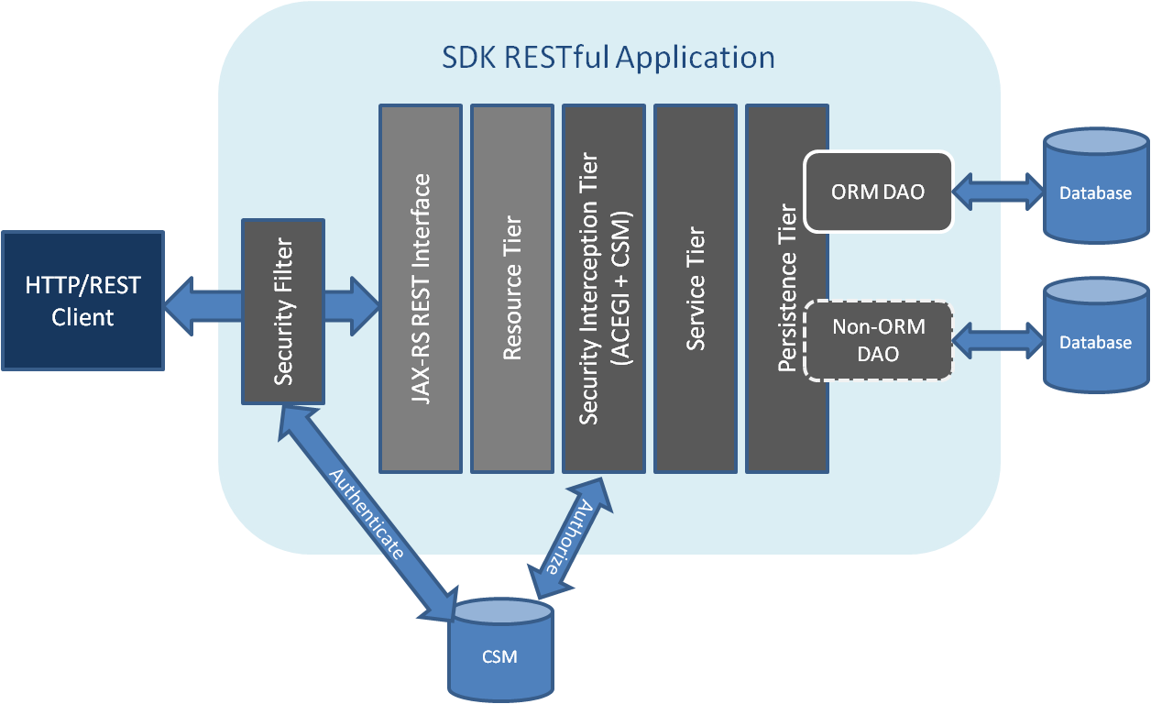
A request from a client would be intercepted by ACEGI security filter to authenticate a user. Default authentication will be supported by CSM. Authenticated request in then passed to JAX-RS REST Servlet that forwards request to mapped resource. Security Interception tier ensures that only the authorized users are allowed to access the system. The security configuration in the SDK is done using the ACEGI and Common Security Module (CSM) developed by NCICB. In the case of the unsecured system, this layer is disabled through the configuration files.
Service tier consolidates incoming requests from the various interfaces and forwards them to the appropriate persistence tier implementation. The default Application Service tier has methods to support ORM based system. The methods are sufficient to support requirements for most applications. The service can also be extended to add any new operations.
The persistence tier is responsible for understanding the query that user has sent and fetching the results corresponding to the query. SDK currently supports persistence tiers created in two ways; object-relational mapping (ORM) based persistence tier and non-object-relational mapping (Non ORM) based persistence tier.

Code generation
The caCORE SDK is comprised of two modules, as shown in the diagram below. The first is the Code Generation Module, which accepts a UML model as input and produces various artifacts corresponding to the model as output, packaged for the Runtime System.
The second module is the Runtime System, which is a pre-built system and utilizes the artifacts generated by the code generation module in order to retrieve data and serve the data to the client application.
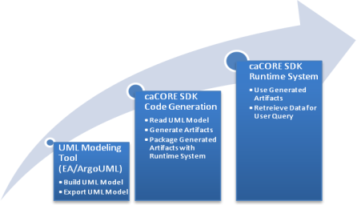

Modular separation of SDK provides an easy fit for JAX-RS RESTful implementation. Code generation module can generate JAX-RS based resources and these resources can be made available through SDK runtime module.

The code generation process involves the following high-level steps to generate the artifacts required.
- Read UML model: SDK supports UML models created in EA or ArgoUML. SDK uses XMIHandler (NCI CBIIT developed packge) to read UML model in Java objects format. SDK performs several validation checks to make sure the model follows SDK supported modeling techniques before performing the next step – Artifact generation. Please see SDK Object Relational Mapping Guide for more details.
- Artifact Generation: The SDK generates various artifacts based on the information that it obtains from the UML model. The artifact can be a Java Bean, O/R Mapping file, or web service deployment descriptor. Most artifacts are generated from the information obtained from the UML model. Other artifacts are generated from the property files and configuration files supplied at the time of running the SDK.
- Output management: When the artifact is generated, the output needs to be written into the file. The file content can be Java source code or XML. If the artifact is a Java program then it needs to be written in a particular folder hierarchy to preserve namespace. Also, all the Java program files require “.java” for their file extension. Similarly, the generated XML documents need to be placed in appropriate folders and assigned appropriate file names and extensions.

In REST based architecture everything is a resource. A resource is accessed via a common interface based on the HTTP standard methods. Every resource should support the HTTP common operations. Resources are identified by global ID's (which are typically URIs). Each domain object from the UML model can be represented as a RESTful resource. Each of these resources can support all CRUD operations. In order to support configurable way of generating RESTful resources and their operations, SDK code generation would need to understand the following:
- Which of the domain objects are RESTful resources?
- Which of the operations supported by each RESTful resource?
Following diagram shows overall process of code generation and runtime configuration. Artifacts generated through code generation process will be packaged and configured to be deployable into JBoss/Tomcat container.

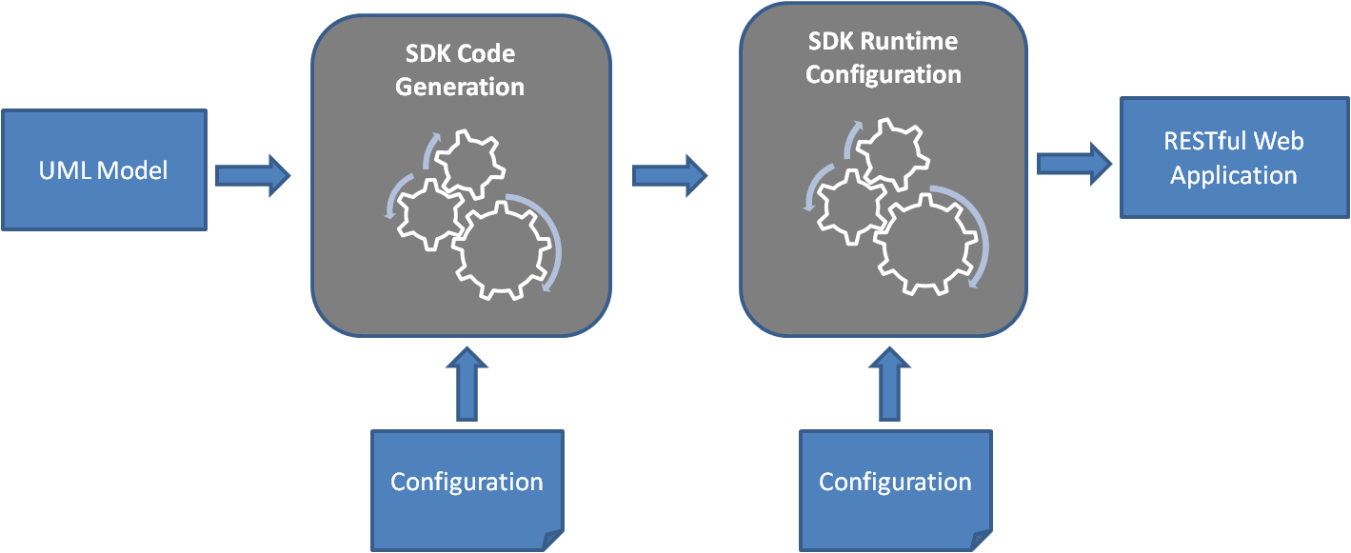

Configuration
As shown in the diagram above, the inputs to the code generation modules are UML model and a configuration file (codegen.properties). SDK uses custom tag values extensively to support mapping between logical and data models and to identify domain objects properties. SDK RESTful implementation will make use of this approach to selectively identify a domain object as a RESTful resource. It would also be used to enable or disable CRUD operations on selected resource. Following custom tag will be introduced as part this implementation:
Custom Tag Name: RESTFUL_RESOURCE
Custom Tag Values: CRUD
This custom tag can be added at package or class level. Class level settings will override package settings.
Following validation rules will be applied to generate a RESTful resource:
Custom tag should at least have one of C R U D values
Domain object should be a concrete class

To further add flexibility in generating RESTful resources, following properties will be added to codegen.properties.

GENERATE_RESTFUL_RESOURCES: This property would enable or disable generating RESTful resources. This property overrides settings in UML model. If this property value is set to “false”, then “RESTFUL_RESOURCE” tag set in a given UML model will be ignored.
RESTFUL_RESOURES_INCLUDE_PACKAGE: This property takes fully qualified Package name. If package name is given, all Classes in the package are included for creation of RESTful resources.
RESTFUL_RESOURES_EXCLUDE_PACKAGE: This property takes fully qualified Class or Package name. If package name is given, all Classes in the package are excluded for creation of RESTful resources.
RESTFUL_RESOURES_EXCLUDE_NAME: This property takes fully qualified Class name to exclude

All packages are first filtered (constrained) by the RESTFUL_RESOURES_INCLUDE_PACKAGE property value, and then further filtered by the EXCLUDE_* values.

Above setting will work in conjunction with following existing properties set for java beans code generation:

INCLUDE_PACKAGE: Specifies the regular expression (java.util.regex) pattern(s) of any fully qualified package names within the object/data model that should be processed by the code generator. Separate patterns using a comma (',') as a delimiter.
EXCLUDE_PACKAGE: Specifies the regular expression (java.util.regex) pattern(s) of the fully qualified package name(s) within the object/data model that should be ignored (not processed) by the code generator. Use a comma (',') as a delimiter to separate patterns.
EXCLUDE_NAME: Specifies the regular expression (java.util.regex) pattern(s) of the fully qualified class name(s) within the object/data model that should be ignored (not processed) by the code generator. Use a comma (',') as a delimiter to separate patterns. NOTE: This property applies only to original fully qualified class names as defined within the UML Logical Model class names, and NOT to any GME Namespace class name(s) that may be present in the model as Tag Values.

If a package is excluded from code generation, it will also be excluded from RESTful resource generation.

Example:
RESTFUL_RESOURES_INCLUDE_PACKAGE=.*
RESTFUL_RESOURES_EXCLUDE_PACKAGE=
EXCLUDE_PACKAGE=gov.nih.nci.domain.Subject

With the above settings, even though RESTFUL_RESOURES_EXCLUDE_PACKAGE doesn’t exclude any packages, it would honor EXCLUDE_PACKAGE value.
EXCLUDE_PACKAGE and EXCLUDE_NAME values would always override RESTFUL_RESOURES_INCLUDE_PACKAGE and RESTFUL_RESOURES_EXCLUDE_PACKAGE properties.

SDK JAX-RS Resources
SDK generated RESTful resources will follow below REST principles.
Addressability: Addressability is the idea that every object and resource in generated application is reachable through a unique identifier. This addressability is managed through the use of URIs. Each RESTful resource generated by SDK can be addressed by unique URI. Using JAX-RS annotations, each generated RESTful resource will be bind with a URI. The @javax.ws.rs.Path annotation in JAX-RS is used to define a URI matching pattern for incoming HTTP requests. It will be placed upon each resource and its operations. The value of the @Path annotation is an expression that denotes a relative URI to the context root of your JAX-RS application.
SDK generated RESTful resource will use domain object name as its resource name. For example: A Bank resource will be addressed as:
http://localhost:8080/example/Bank
Using a pattern /Bank/{id}, where {id} string is a pattern that represents an individual Bank.
Operations: SDK 4.5 will start supporting GET, PUT, POST, DELETE operations on each of the resources generated. This capability works in conjunction with ENABLE_WRITABLE_API_EXTENSION property value. If ENABLE_WRITABLE_API_EXTENSION is set to false, generated RESTful resources would only support GET operation. All other (PUT, POST, DELETE) operations will not be generated as part of RESTful resource generation. This option would let users support query only resources.

GET: SDK generated RESTful resources can be addressed by client applications through:

/{resource_name}/{id}
This would find a matching domain objects for a given id
Ex: http://localhost:29080/examplerest/rest/Card/1

/{resource_name}/search;<attr=value>;<attr=value>….
This would return all domain objects of the resource matching with domain object search attributes. <attr=value> combination supports operators < (less than), > (greater than) and != (not equal) on number data types. Value part of the combination supports “*” including in it to query based on wildcard search.
Ex: http://localhost:29080/examplerest/rest/Card/search;id=1;name=Ace
Ex: http://localhost:29080/examplerest/rest/Card/search;id=1;name=A*
Ex: http://localhost:29080/examplerest/rest/Card/search;id>10;name=Ace

/{resource_name}/{id}/{association_name}
This would return associated domain object(s) to the matched domain object
Ex: http://localhost:29080/examplerest/rest/Card/1/suit

/{resource_name}/search;<attr=value>;<attr=value>…./{association_name}
This would return all domain objects of the resource matching with domain object search attributes. <attr=value> combination supports operators < (less than), > (greater than) and != (not equal) on number data types. Value part of the combination supports “*” including in it to query based on wildcard search.
Ex: http://localhost:29080/examplerest/rest/Card/search;id=1;name=Ace/suit
Ex: http://localhost:29080/examplerest/rest/Card/search;id=1;name=A*/suit
Ex: http://localhost:29080/examplerest/rest/Card/search;id>10;name=Ace/suit

When serving GET operation on bulk results SDK would follow paging mechanism so that the response would not overload its client. To mitigate this problem, SDK RESTful resource will allow the client to specify query parameters on the URI to limit the size of the dataset returned:
Ex: http://localhost:29080/examplerest/rest/Card/search;name=*?start=0&size=10

These parameters will be optional. The client does not have to specify them in its URI when crafting its request to the server. If no query parameters are given, SDK will use property value set for RESTFUL_PAGE_SIZE in codegen.properties.

PUT: SDK will use this operation to add a resource. URI format for this operation would be <url>/<resource name>. The HTTP definition of PUT states that it can be used to create or update a resource on the server. PUT operation will use SDK WritableAPI process internally where it allow users to specify primary key generator per root class. Global setting for primary key generator will be specified in codegen.properties configuration file. Class level setting will be specified in the UML model. SDK will assume global setting for any class which does not have a specific primary key generator assigned.

To create an entry with PUT, the client simply sends XML representation of the new object it is creating to the exact URI location that represents the object:
PUT /Card
PUT /Suit

SDK RESTful service receives the PUT message, processes the XML, and creates a new entity in the database using a database-generated unique ID. SDK API takes care of updating the associations based on cascade and inverse-of settings. The client would receive a response message something like this:
<?xml version="1.0" encoding="UTF-8">
<response>
<type>MESSAGE</type>
<code>CREATE</code>
<resource>Card</resource>
<path>PUT</path>
<message>http://localhost:29080/examplerest/rest/Card/6</message>
</response>

When a resource is created with PUT, the HTTP specification requires sending a response code of 200, “OK” and a response message body or a response code of 204, “No Content” without any response body. SDK RESTful implementation will send a status of 200 and the URI for newly created resource as part of the response message.

POST: SDK will use this operation to let a client program to update an entity to the resource. URI format for this operation would be <url>/<resource name>. A client sends XML representation of existing object to the resource URI of its representation.

SDK RESTful service receives the POST message, processes the XML, and updates existing entity in the database. SDK API takes care of updating the associations based on cascade and inverse-of settings. The client would receive a response message something like this:

<?xml version="1.0" encoding="UTF-8">
<response>
<type>MESSAGE</type>
<code>UPDATE</code>
<resource>Card</resource>
<path>POST</path>
<message>Successfully updated Card</message>
</response>

DELETE: SDK will use this operation to let a client program delete a resource with its Id. URI format for this operation would be <url>/<resource name>/<id>

Example:
http://localhost:29080/example/PrivateTeacher/1

When a resource is removed with DELETE, the HTTP specification requires that you send a response code of 200, “OK” and a response message body or a response code of 204, “No Content” without any response body. SDK RESTful implementation will send a status of 200 and response message. The client would receive a response message something like this:
<?xml version=\"1.0\" encoding=\"UTF-8\"?>
<response>
<type>MESSAGE</type>
<code>DELETE</code>
<resource>PrivateTeacher</resource>
<path>DELETE</path>
<message>Successfully deleted PrivateTeacher with ID: 1</message>
</response>

SDK API will take care of updating the associations based on cascade and inverse-of settings on the deleted resource.

Representation
In a RESTful system, for each service that is addressable through a specific URI, representations are exchanged between the client and service. These representations could be XML, JSON, YAML, etc. SDK RESTful implementation will use XML as the representation to represent data over the wire to its clients.
Each representation will have a common XML element called link:
<link rel="self" type=”application/xml” href="http://localhost:29080/examplerest/rest/Card/1"/>

The “link” element tells any client that obtains an XML document describing one of the objects linked to the resource that the client can interact with. The “rel” attribute tells the client what relationship the link has with the resource the URI points to (contained within the href attribute). The “self” value just means it is pointing to itself.
SDK makes use of Hypermedia As The Engine Of Application State (HATEOAS) principle where a representation could have embedding links to other services and information within.
One of the uses of hypermedia and hyperlinks is composing complex sets of information from disparate sources. SDK generated RESTful resources represents association data through links without bloating its responses.
<Card xmlns="gme://caCORE.caCORE/3.2/gov.nih.nci.cacoresdk.domain.other.levelassociation" xmlns:xsi="http://www.w3.org/2001/XMLSchema-instance" name="Ten" id="10" xsi:schemaLocation="gme://caCORE.caCORE/4.5/gov.nih.nci.cacoresdk.domain.other.levelassociation gov.nih.nci.cacoresdk.domain.other.levelassociation.xsd">
<link xmlns="" ref="self" type="application/xml" href="http://localhost:29080/examplerest/rest/Card/10"/>
<link xmlns="" ref="suit" type="application/xml" href="http://localhost:29080/examplerest/rest/Suit/1"/>
</Card>

Same approach is used for paging large result sets where “next” and “previous” links can be used to navigate through the resultset.
<Cards xmlns="gme://caCORE.caCORE/4.5/">
<link xmlns="" ref="next" type="application/xml" href="http://localhost:29080/examplerest/rest/Card/search;name=*?start=12&size=2"/>
<link xmlns="" ref="previous" type="application/xml" href="http://localhost:29080/examplerest/rest/Card/search;name=*?start=8&size=2"/>
<link xmlns="" ref="self" type="application/xml" href="http://localhost:29080/examplerest/rest/Card/search;name=*"/>
<Card xmlns="gme://caCORE.caCORE/3.2/gov.nih.nci.cacoresdk.domain.other.levelassociation" xmlns:xsi="http://www.w3.org/2001/XMLSchema-instance" name="Ten" id="10"xsi:schemaLocation="gme://caCORE.caCORE/4.5/gov.nih.nci.cacoresdk.domain.other.levelassociation gov.nih.nci.cacoresdk.domain.other.levelassociation.xsd">
<link xmlns="" ref="self" type="application/xml" href="http://localhost:29080/examplerest/rest/Card/10"/>
<link xmlns="" ref="suit" type="application/xml" href="http://localhost:29080/examplerest/rest/Suit/1"/>
</Card>
<Card xmlns="gme://caCORE.caCORE/3.2/gov.nih.nci.cacoresdk.domain.other.levelassociation" xmlns:xsi="http://www.w3.org/2001/XMLSchema-instance" name="Jack" id="11"xsi:schemaLocation="gme://caCORE.caCORE/3.2/gov.nih.nci.cacoresdk.domain.other.levelassociation gov.nih.nci.cacoresdk.domain.other.levelassociation.xsd">
<link xmlns="" ref="self" type="application/xml" href="http://localhost:29080/examplerest/rest/Card/11"/>
<link xmlns="" ref="suit" type="application/xml" href="http://localhost:29080/examplerest/rest/Suit/1"/>
</Card>
</Cards>

Content Handling
SDK currently has been using JAXB marshalling and unmarshalling to transmit data between a client and its service interface. SDK does this by using annotated Java beans and custom JAXB marshaller and unmarshaller implementations. SDK RESTful implementation will use existing implementation to marshall and unmarshall to/from Java object using JAXB.

Error Handling
The default response codes that JAX-RS uses are pretty straightforward. The HTTP specification is consistent for the PUT, POST, GET, DELETE methods. Successful HTTP response code numbers range from 200 to 399. Standard HTTP error response code numbers range from 400 to 599. This allows for throwing a checked or runtime exception from an application code and maps it to an HTTP response in a registered provider.
JAX-RS has a RuntimeException class, WebApplicationException, that allows to abort a JAX-RS service method. It can take an HTTP status code or even a Response object as one of its constructor parameters. SDK RESTful implementation will use WebApplicationException to report any standard errors. Beyond WebApplicationException, SDK will map non-JAXRS exceptions that might be thrown by SDK data layer to a Response object by registering implementations of the ExceptionMapper class. ExceptionMappers are custom, application provided, components that can catch thrown application exceptions and write specific HTTP responses.

Security
The caCORE SDK generated middleware system has built-in security that is capable of performing authentication and authorization. In order to manage authentication, the user has a variety of options, which are supported by the Common Security Module (CSM). The CSM API allows use of LDAP, RDBMS and other JAAS based login modules for authentication purposes.
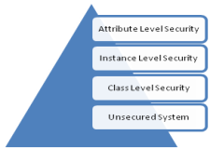
caCORE SDK provides security at various levels: Class level security, Instance level security, Attribute level security or Unsecured system (No security). Below is brief description of each level.
- Unsecured system (No Security) – All the users of caCORE SDK have equal access to the data that the runtime system serves.
- Class level security – Only users who have access to certain objects in the system can query for the data. For example, doctors can view patient data whereas an administrator cannot.
- Instance level security – Users are allowed to access data for only the records to which they are given access. For example, doctors can view data for their patients only and for no other patients in the system.
- Attribute level security – Users are allowed to only see data for which they are authorized. For example, doctors are allowed to see a patient's medical record number but they cannot see the patient's social security number.

Configuration of the level of security to be enabled is managed through the configuration file (install.properties) at the time of system deployment. When security is enabled, the system applies class level security by default. SDK generated RESTful resources will use SDK built-in security.
Authentication:
Authentication is about validating the identity of a client that is trying to access SDK RESTful resources. SDK generated RESTful resources will support BASIC authentication type. Basic authentication is the simplest protocol available for performing authentication over HTTP. It involves sending a Base64-encoded username and password within a request header to the server. The server checks to see if the username exists within its system and verifies the sent password. To perform authentication, the client must send a request with the Authorization header set to a Base64-encoded string of our username and a colon character, followed by the password. The client needs to send this Authorization header with each and every request it makes to the server.
Authorization:
Authenticated client will proceed to authorization where user will be checked for enough permission to perform requested action on the resource. SDK will make use of its internal implementation of CSM to perform authorization. CSM UPT is a security provisioning tool where security for RESTful resources can be configured as detailed in security configuration section below.
Encryption:
When a client is interacting with a RESTful web service, it is possible for hostile individuals to intercept network packets and read requests and responses if your HTTP connection is not secure. Sensitive data should be protected with cryptographic services like SSL. This is part of container configuration which is out of scope for this document.

Configuring Security
Security in SDK is provided by ACEGI and CSM. Users of the SDK need who intend to use security can do so in three steps
- Configure security related properties. Users can do so by altering the configuration parameters in the install.properties file before generating the system.
- Configure Application Server for JAAS based authentication configuration
- Setup CSM database configuration for SDK based application
Table given below shows the properties that the user has to modify in order to correctly enable the security in SDK.
Property Name | Default Value | Description
SECURITY_ENABLED | false | Used to enable or disable security within the generated system during code generation.  This applies to all of the SDK interfaces, including:  - Web Interface (GUI)  - Java API Interface (local and remote clients)  - Web Service Interface
CSM_PROJECT_NAME | sdk | Used as a prefix when creating the CSM security configuration file name. CSM configuration should have the same application name configured
INSTANCE_LEVEL  _SECURITY | false | Used to enable/disable CSM instance level security.  Only relevant if the SECURITY_ENABLED property is set to ‘true’
ATTRIBUTE_LEVEL  _SECURITY | false | Used to enable/disable attribute level security.  Only relevant if the SECURITY_ENABLED property is set to ‘true’
CSM_USE_JNDI  _BASED_CONNECTION | no | Indicates whether a JNDI DB connection should be used for the CSM database.  If USE_JNDI_BASED_CONNECTION=yes, then the DB_JNDI_URL property value is used to obtain the DB connection and retrieve data
CSM_DB_JNDI_URL | java:/SDK | The DB JNDI URL value for the CSM database.  This property is irrelevant/ignored if CSM_USE_JNDI_BASED_CONNECTION=no
CSM_DB_CONNECTION_URL  CSM_DB_USERNAME  CSM_DB_PASSWORD | none | The CSM database connection properties.  A sample DB_CONNECTION_URL value: jdbc:oracle:thin:@cbiodb30.nci.nih.gov  :1521:CBTEST  These values are purposely blank. SDK users should provide appropriate values for their CSM database instance within the local.properties file located in the root folder of the SDK distribution.
CSM_DB_DIALECT | org.hibernate.dialect.OracleDialect | The Hibernate Database dialect used when connecting to the CSM database.  Typical values include:  - org.hibernate.dialect.OracleDialect  - org.hibernate.dialect.MySQLDialect

Users of caCORE SDK will have to setup a CSM database schema and configure it with CSM’s User Provisioning Tool (UPT). While configuring the security schema with UPT, user of the SDK is required to create Protection Element for each domain object in the SDK generated system. The protection element should have the name as fully qualified name of the domain object. Security implementation of SDK uses the name of the domain object as a key to be searched in the CSM configuration to determine access privileges. Figure shown below demonstrates addition of the StringKey class as a protection element in the CSM.
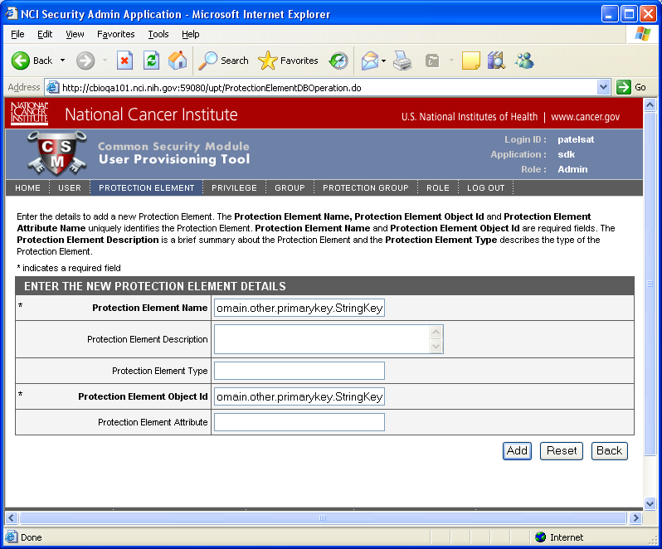
Once all the protection elements are created, user of the SDK can create users, user groups and assign them CREATE, READ, UPDATE, DELETE privileges to appropriate protection elements based on the security needs of the application.

3.6 Discovery
JAX-RS service endpoints can be listed in the service listings page and users can check the WADL documents. WADL is a resource-centric description language which has been designed to facilitate the modeling, description and testing of RESTful Web applications. SDK RESTful web application will provide service listings that will list instances WADL registered at that endpoint.
Ex:
http://localhost:21080/examplerest/rest/services
http://localhost:21080/examplerest/rest/?_wadl&_type=xml

A WADL can also be obtained using following URL format:
http://localhost:21080/examplerest/rest/Card?_wadl&_type=xml

3.7 Reference Implementation
As part of SDK runtime system, SDK provides a reference implementation to query domain objects based on its attribute criteria. This web application will be extended to provide all CRUD operations using RESTful resources.
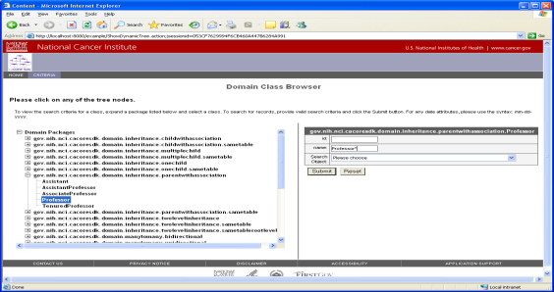
Search criteria page will provide link to create a record. Record creation page will expect user to fill in any association keys to create it. Search results page will provide links delete or update individual records.
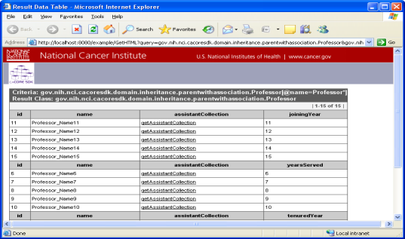
Reference implementation will also provide thin client implementation to perform CRUD operations using SDK generated RESTful application.

3.8 Supporting existing Implementations

SDK 4.5 will continue to provide existing REST-like implementation to support any existing customers before it is retired in future releases.
Following link provides details on existing REST-like implementation:
https://wiki.nci.nih.gov/display/caCORE/8.2+-+XML-JSON-HTTP+Interface+for+caCORE+SDK+4.4

ERROR MESSAGES:
For missing search critieria:
<?xml version=\"1.0\" encoding=\"UTF-8\"?>
<response>
<type>ERROR</type>
<code>SEARCH_CRITERIA_1</code>
<message>Search criteria is missing</message>
<valid>
<attribute>
</attribute>
</valid>
</response>

For invalid search critieria:
<?xml version=\"1.0\" encoding=\"UTF-8\"?>
<response>
<type>ERROR</type>
<code>SEARCH_CRITERIA_1</code>
<message>Search criteria is missing</message>
<valid>
<attribute>
</attribute>
</valid>
<invalid>
<attribute>
</attribute>
</invalid>
</response>

